GCRCC Rules

Approved by GCRCC Membership 3/30/2023
Amended 2010, 2014, 2016, 2017, 2023

Flight Rules

- All pilots must comply with the AMA Safety Code and Safe Handbook. This code is posted on the bulletin board at the field and can be found in the AMA Membership Application and on the AMA website.
- All members and guests must have appropriate AMA membership and FAA UAS registration to fly.

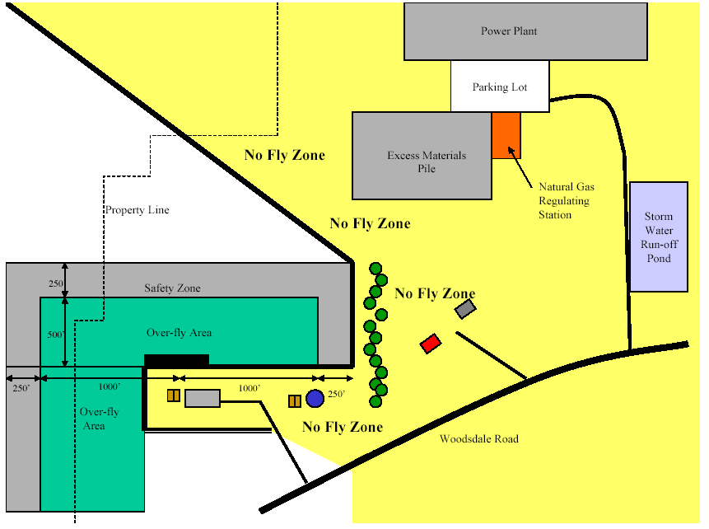

- All pilots flying aircraft at the GCRCC Field must obey the boundaries of the field and avoid the "NO FLY ZONE". Respect the eastern field boundary to avoid overflight of our neighbor, the Chrisholm Historic Farmstead.
- Aircraft propulsions systems may not be started in the pit area unless the pilot has the proper frequency pin, and the Aircraft is pointed in a safe direction and properly restrained. Prop wash and jet blast should not be aimed at other planes or people. Ensure that all people are behind propeller or clear of the jet blast before the propulsion system’s throttle is advanced.
- When flying from the paved east-west runway, flying south of the runway is not permitted except for emergencies. When flying from the unpaved north-south runway, flying east of the runway is not permitted except for emergencies. Flying over the pit area is never permitted. Pilots must stand on the marked pilot line when flying on paved runway or a mutually agreed upon line when flying on the unpaved runway.
- A pilot should announce their intentions prior to carrying or taxing a plane to the runway, taking off or landing. Dead stick landings should be announced and have preference over other operations. To retrieve aircraft stopped anywhere in front of the pilot line, walk behind other pilots to a point closest to the aircraft and announce intention before crossing the pilot line onto the runway.
- Take offs and landings should be made into the prevailing wind. In the event of a cross wind or no wind, the active pilots should agree on a direction.
- High-speed low passes should be made parallel to the active runway and to the far side as viewed from the pilot stations.
- No flying may occur while the field is being mowed without prior consent of mower operators.
- A pilot about to make a "maiden" flight or the first flight after repair must inform the others on the flight line and in the pit area. This ensures that everyone is alert in the event of a problem.
- New members and students are not permitted to fly at the GCRCC field unless they are under the direct supervision of a GCRCC instructor or have been "signed off" by two GCRCC instructors.
The board appoints instructors for each flying season upon the recommendation of the training coordinator.
- GCRCC members may host up to two non-members per day to fly at the GCRCC field. Local non-members (residents of Hamilton or adjacent counties) may fly as guests up to twice per year. Any non-member irrespective of residency may fly as a part of a GCRCC sanctioned event.
- Non-AMA members may receive one demonstration flight with a buddy box under the control of a GCRCC instructor. The plane must be owned by a GCRCC member.
- When frequency control pins are in use, you must have the proper pin in your possession before you turn on your transmitter. When you pick up the pin from the rack, place your GCRCC Membership Card in its place. Return the pin to the rack after your flight and after your transmitter has been turned off and remove your card. Note: When the pins are not in use, it is your responsibility to make sure your frequency is clear before turning on your transmitter.
Equipment Rules

- Channel number/frequency is required to be clearly displayed on all transmitters.
- Your name and address must be placed in your model, or your AMA membership number must be displayed on your model.
- Mufflers are required on all 2-cycle engines of 0.10 cubic inch displacement and larger. Mufflers must be an enclosed, expansion chamber type. Engines with tuned pipes are considered muffled. Engines that seem too nosy will be checked against AMA guidelines.
- A proper spinner or lock nut is highly recommended on all engines. The single nut and washer that came with your engine should not be used without a spinner or lock nut.
- All radio equipment used at the GCRCC field or sanctioned event must meet the 1991 AMA requirements
- The GCRCC highly recommends that EZ connectors not be used on glow or gas powered airplanes for the control surfaces--rudder, elevator and aileron.
Site Rules

- All spectators must remain behind the spectator line at all times. Any small children must be accompanied by and under the control of a supervising adult.
- The last person to leave the field is responsible for locking the front gate. The GCRCC combination lock must be connected between the chain and the Duke padlock. Please be sure the lock is reset to read 0-0-0-0 at all times.
- Models may not be fueled or started on picnic tables, under the shelter or on the assembly tables.
- The picnic facilities are for use by Duke Woodsdale Power Plant employees, GCRCC members and their immediate families and guests.
- No glow or gas powered boats on the pond.
- No models, flight boxes and/or equipment are permitted on the tables in the Duke shelter.
- It is your responsibility to remove your trash and leave the field clean.
- All pets shall be kept on a leash, pets shall remain on the spectator side of the fence, pets must be under the supervision of their owner. Pet owners are required to clean up after their pets. Pets that display aggressive behavior shall not be permitted at the field. Aggressive behavior shall include but not be limited to: growling, barking, chasing people, urinating on others property, and entering other’s vehicles.

